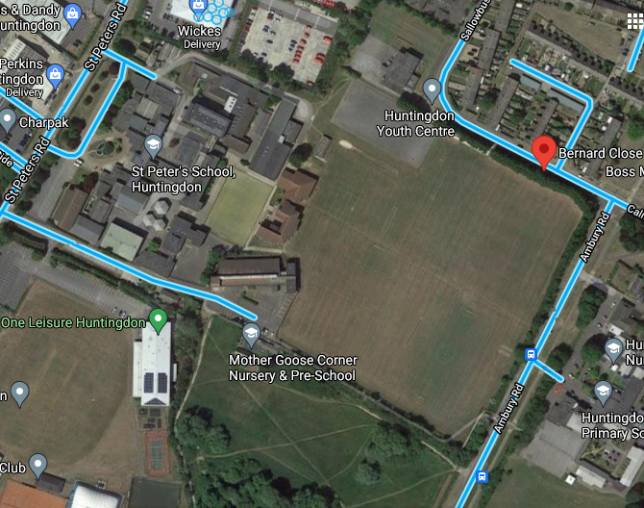

At St Peter’s School we promote sustainable travel and encourage students to walk or cycle to school.

There are pavements with cycling paths for use by students on Sallowbush Road and Ambury Road. There are gates for students to use on Ambury Road and the road by One Leisure.

St Peter’s School map showing gates to be used when arriving at/leaving school. 

Please see below for safety advice for students and parents planning journeys to school from <https://www.think.gov.uk/>

**Advice for cyclists**

([www.think.gov.uk/cycle-safety/](http://www.think.gov.uk/cycle-safety/))

* Ride decisively and keep clear of the kerb.
* Look and signal to show drivers what you plan to do, make eye contact where possible.
* Avoid riding up the inside of vehicles, as you might not be seen. If a vehicle is indicating to the left hang back at the junction to reduce the risk of a collision.
* Always use lights after dark or when visibility is poor. Wear high-visibility and reflective clothing and accessories at all times
* Wear a correctly fitted cycle helmet that is securely fastened and conforms to current regulations.
* Your local council can help you plan your journey by providing maps showing dedicated paths and routes.
* Where possible, try to maintain [**social distancing**](https://www.gov.uk/government/publications/staying-alert-and-safe-social-distancing/staying-alert-and-safe-social-distancing) when you cycle, for example when waiting at crossings and traffic lights.
* Where using bikes (private, docked or dockless) wash your hands for at least 20 seconds or sanitise your hands before and after cycling.
* **Read more**
* [**Highway Code rules for cyclists**](https://www.gov.uk/rules-for-cyclists-59-to-82)

